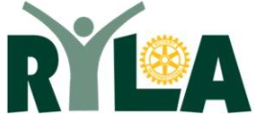
Rotary Youth Leadership Awards
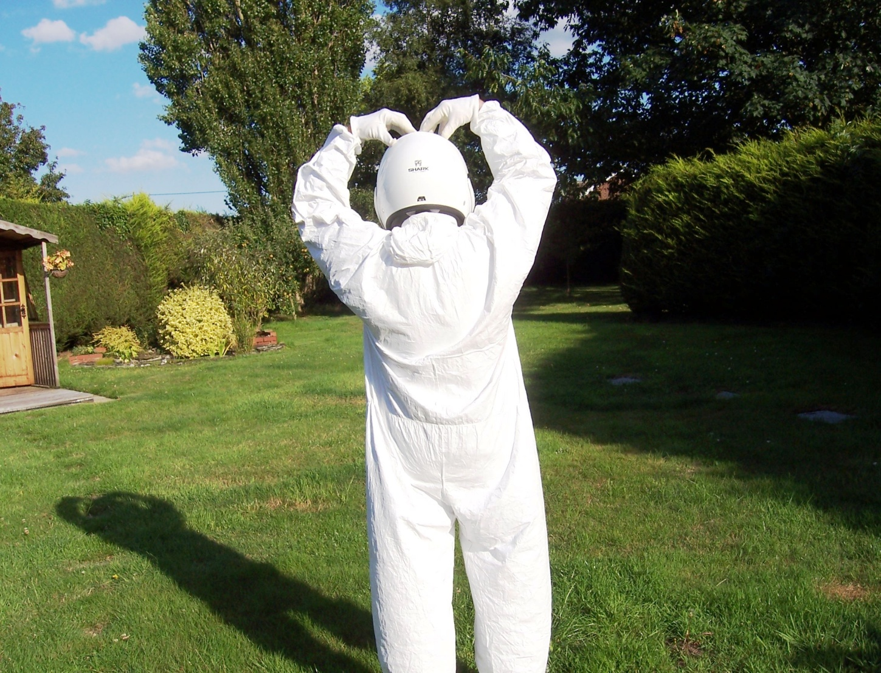
27th Aug to 3rd Sept 2022
Grafham Water Centre
£TBC per Delegate

Restricted to 50 delegates
BOOK NOW
www.ryla.co.uk

Visits/information etc. David Simpson
01394 385839(H) 07718 889482(M)
Email: davidrsimpsoncar@btinternet.com

A life changing experience
for people age 18 to 26

